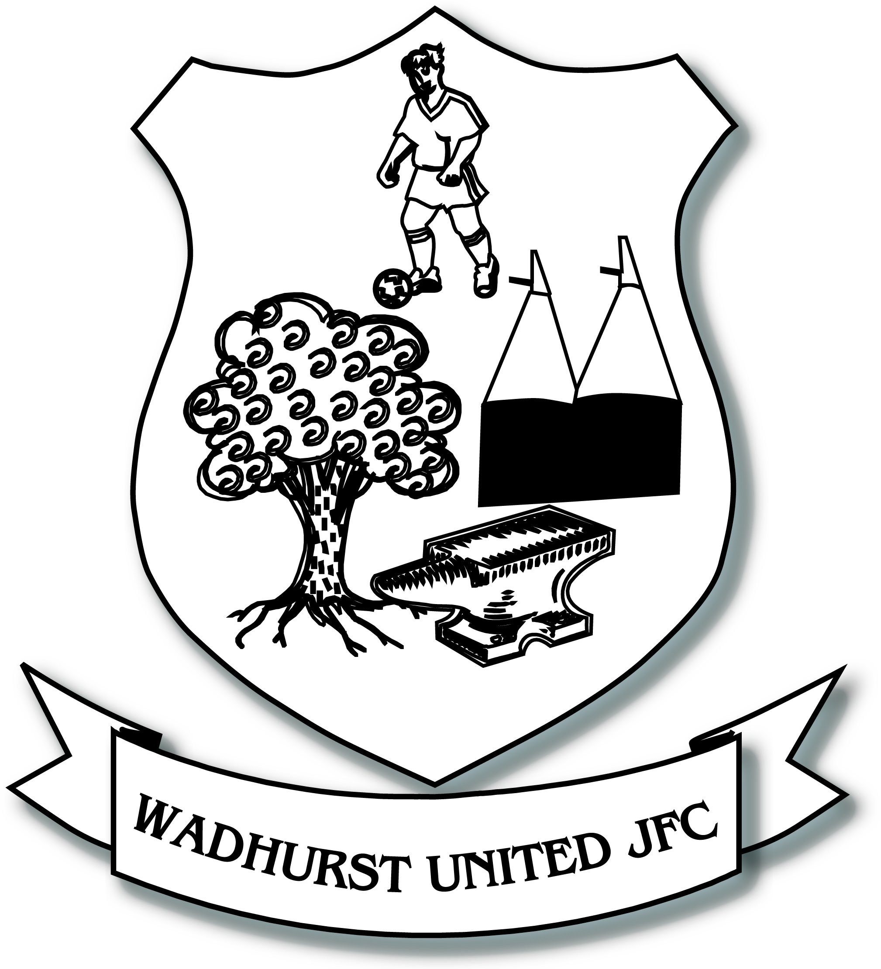
Wadhurst United JFC
Player Code of Conduct
______________________________________________________________________
Everyone involved in football has a responsibility to promote high standards of behaviour in the game. As a player, you have a big part to play. That’s why The FA is asking every player to follow a Respect Code of Conduct.
When playing football, I will:
- Always play to the best of my ability
- Play fairly – I won’t cheat, complain or waste time
- Respect my team-mates, the other team, the referee and my coach/manager
- Play by the rules, as directed by the referee
- Shake hands with the other team and referee at the end of the game
- Listen and respond to what my coach/team manager tells me and ask if I do not understand
- Talk to someone I trust or the Club Welfare Officer if I’m unhappy about anything at my club
In addition, as a member of Wadhurst JFC I agree to:
- Ensure that I arrive for training and matches correctly attired
- Attend training on a regular basis
- Learn to accept success, failure, victory and defeat
- Not to engage in any form of bullying, fighting or use of inappropriate language
- Act in a manner that is a credit to both myself, my team and the club
- Encourage each other and be supportive at all times
- Do not cause damage to the club’s property or equipment
I understand that if I do not follow the Code of Conduct, any/all of the following actions may be taken by my Club, County FA or The FA:
- Be required to apologise to my team-mates, the other team, referee or team manager
- Receive a formal warning from the coach or the club committee
- Be dropped or substituted
- Be suspended from training
- Be require to leave the Club
As a player under 18, my parent/guardian and my Club will be made aware of the infringements of the Code of Conduct and I’m aware that both myself and the club may receive a fine and suspension from County FA.
______________________________________________________________________

